This week, I learned about Google login, which is a way to connect Google users and the service portal.

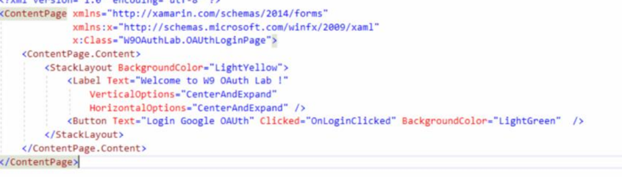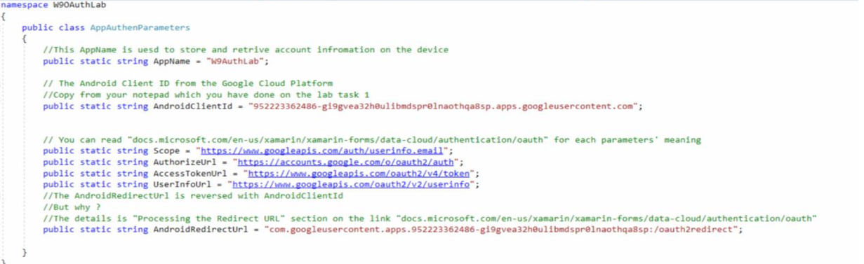

Then get the result :

